
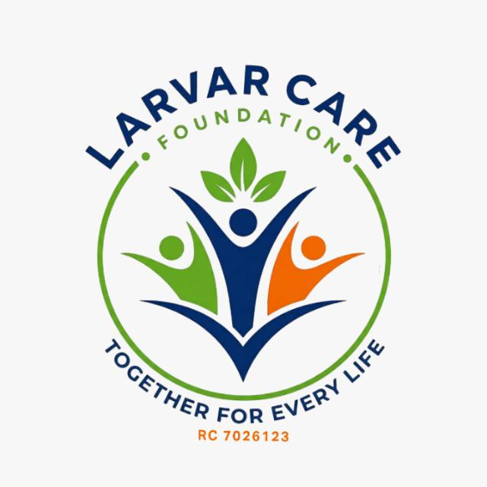

LARVAR CARE FOUNDATION
PILOT ASSESSMENT REPORT
MOVING TOWARDS SOLUTION PATHWAYS
Adamawa State, Nigeria
Evidence for Durable Solutions, Recovery and Reintegration

940  SITES ASSESSED | 207,799  HOUSEHOLDS | 1,280,973  INDIVIDUALS

Pilot Round | Site-level assessment | Adamawa State

1. Executive Summary
This pilot assessment provides an evidence base for partners working to move displaced and returnee populations from prolonged displacement toward safe, dignified and sustainable solutions. The assessment covers 940 sites, 207,799 households and 1,280,973 individuals across 21 LGAs and five population categories: Returnees, IDPs dispersed in Host Communities, IDPs in Camps, IDPs Integrated and IDPs Relocated.
The overall picture is one of a predominantly protracted displacement context in which return is already the dominant recorded pathway. Returnees account for 1,010,715 individuals (78.9%), while 223,104 individuals (17.4%) remain dispersed in host communities. Camp-based IDPs account for 22,872 individuals (1.8%), with smaller populations recorded as relocated (14,180) or integrated (10,102).
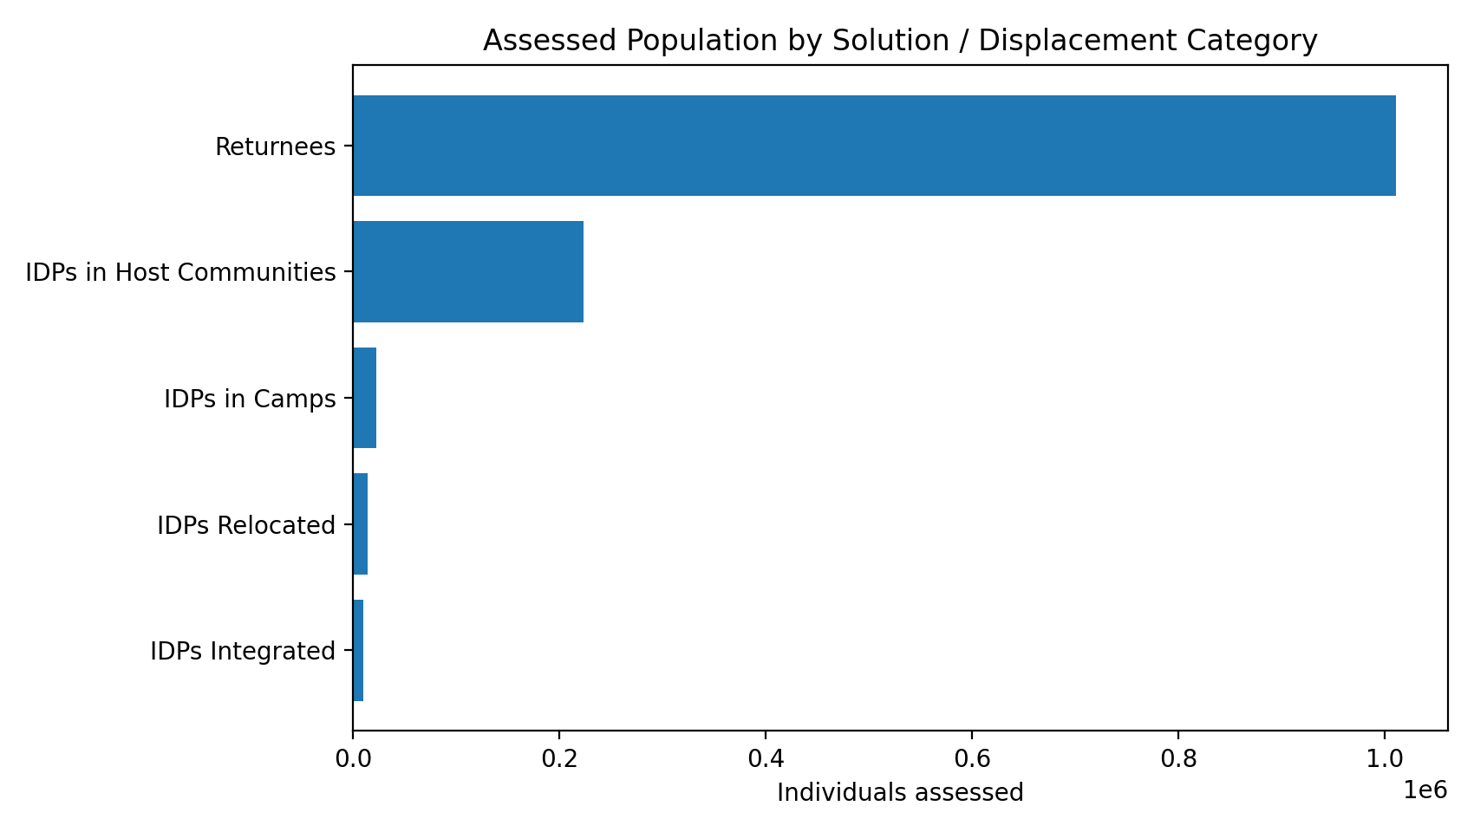

What the evidence tells partners
- Durable solutions should be central to planning: 83% of assessed households arrived at their current location before 2022, indicating a long-standing caseload.
- Return is strongly associated with improved security; insurgency was cited as the displacement driver at 87% of assessed sites.
- Host-community displacement is significant and can be less visible than camp-based caseloads; service planning should therefore follow population presence, not only camp locations.
- Children and youth under 18 represent approximately 662,000 people, highlighting the importance of education continuity, child protection and nutrition across return and host-community settings.
- Shelter recovery remains a priority in selected LGAs, with particularly high reported damage in Shelleng, Mayo-Belwa, Yola South, Madagali, Demsa and Girei.

2. Population and Solution Pathways
Category | Sites | Households | Individuals
Returnees | 403 | 160,624 | 1,010,715
IDPs in Host Communities | 487 | 39,761 | 223,104
IDPs in Camps | 23 | 3,665 | 22,872
IDPs Relocated | 12 | 1,888 | 14,180
IDPs Integrated | 15 | 1,861 | 10,102
Returnees form the largest recorded population, while host-community IDPs constitute the largest group still living away from their places of origin. Camp and integrated populations are comparatively smaller in this pilot round, but remain important for targeted protection, services and transition planning.

3. Priority Investment Areas
01 | Safety & Protection
Sustain protection monitoring and safety-of-return assessments, particularly in high-return LGAs. Security was cited at 815 of 940 sites as the primary displacement driver.
02 | Shelter, Housing & Reconstruction
Prioritise areas with high shelter damage, including Shelleng, Mayo-Belwa, Yola South, Madagali, Demsa and Girei.
03 | Livelihoods & Economic Recovery
Support household economic recovery and productive assets to strengthen the sustainability of return and reduce risks of secondary displacement.
04 | Services in Host Communities
Scale WASH, health and education according to actual population presence, particularly in host-community concentrations.
05 | Child & Maternal Wellbeing
Target education, child protection, nutrition and maternal-health services using the strong child/youth and female demographic profile.
06 | Data, Coordination & Evidence
Use future assessment rounds to establish trends and strengthen disaggregation by pathway, geography, vulnerability and service access.

4. Geographic Priorities
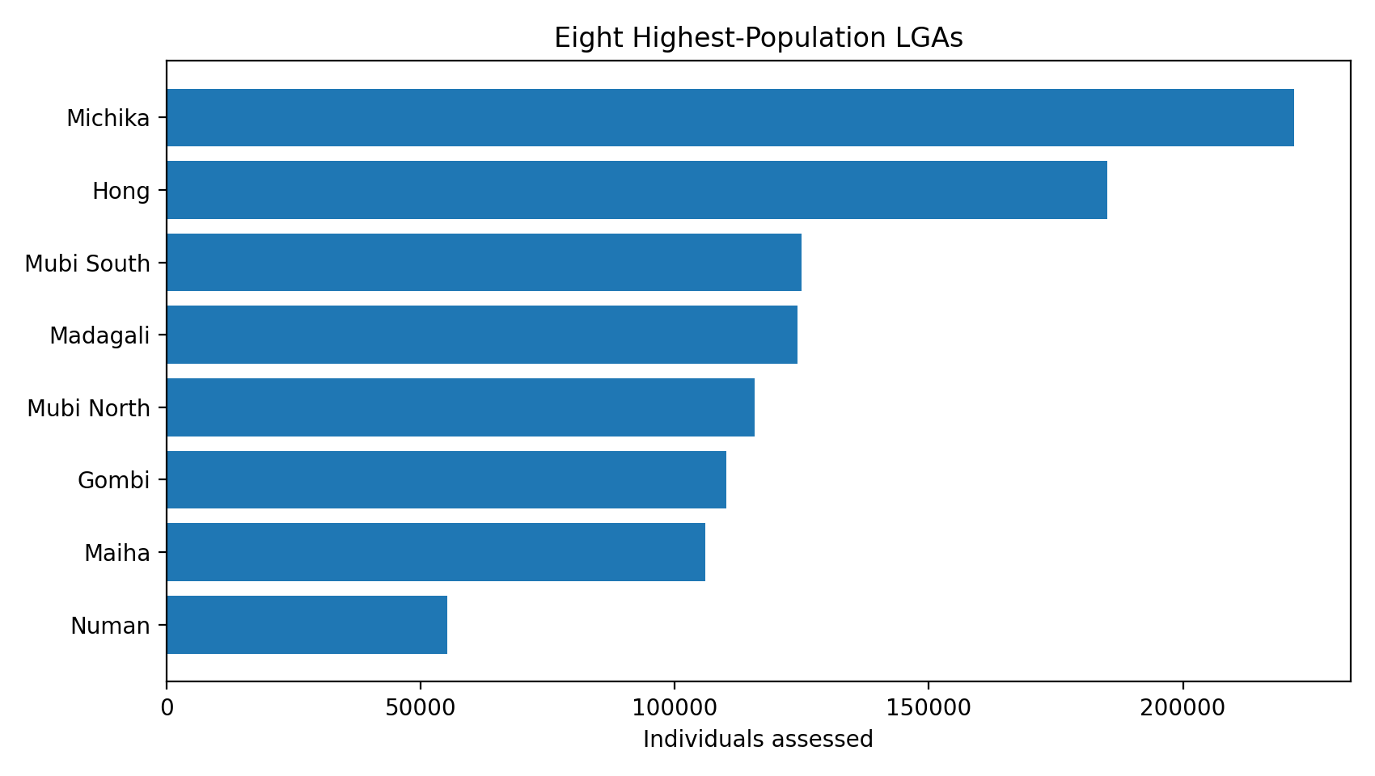
The four highest-population LGAs—Michika, Hong, Mubi South and Madagali—account for 656,051 individuals, or 51% of the assessed population. Michika and Hong report only host-community and returnee populations in this round, with no formal camp, integrated or relocated populations recorded.

5. Demographic Profile and Inclusion
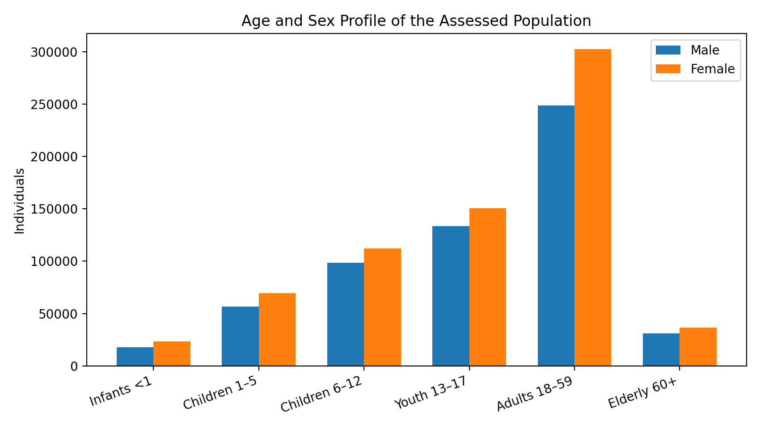
The assessment records women and girls outnumbering men and boys across every age band. Working-age adults account for 550,881 individuals, while youth aged 13–17 account for 284,019. Children and youth under 18 total approximately 662,000 individuals. The vulnerability indicators also include 66,923 elderly persons, 45,813 breastfeeding mothers, 18,126 pregnant women, 8,114 single-female-headed households, 4,106 single-male-headed households, 2,331 orphaned minors, 941 child-headed households and 430 unaccompanied children.

6. Displacement Profile and Implications
Conflict remains the principal reported driver: insurgency was cited at 815 sites (87%), followed by communal clashes at 106 sites (11%). The timeline confirms a predominantly protracted situation: 172,115 households, representing 1,069,146 individuals, arrived at their current locations before 2022. Among returnees, 135,045 of 160,624 households (84%) reportedly returned before 2022.
For partners, this profile shifts the programming emphasis from short-term emergency assistance alone toward durable solutions, recovery, local integration support, permanent shelter and livelihoods, while maintaining protection and essential services.

7. Shelter and Reconstruction Priorities
Among assessed returnee households, 133,401 reported no shelter damage, 17,683 reported partial damage and 9,540 reported full damage. Damage is highly uneven geographically: Shelleng and Mayo-Belwa report 100% of assessed households with damaged shelters; Madagali reports 67%; Yola South 68%; Demsa 67%; and Girei 66%.

8. Recommendations for Government and Partners
- Adopt a pathway-based approach that distinguishes the needs of people still displaced, those integrating locally, those relocated, and those who have returned.
- Develop area-based durable-solutions packages in high-priority LGAs, linking shelter, land, livelihoods, basic services and protection.
- Strengthen host-community service capacity, particularly where displaced populations are dispersed outside formal camps.
- Integrate child protection, education, nutrition and maternal-health actions into both return and host-community programming.
- Use participatory community engagement to ensure interventions are safe, voluntary, dignified, inclusive and locally owned.
- Establish a routine assessment cycle so partners can measure changes in population movement, service access, shelter recovery and solution sustainability over time.
- Strengthen government-led coordination and data interoperability among relevant state and national institutions and humanitarian/development partners.

9. Data and Methodology Note
The source of the data is LARVAR CARE Foundation, using locations identified by DTM Nigeria. Population categories follow the LCF pilot taxonomy. The dataset does not carry a separate distinction between formal and informal camps because the relevant site-classification fields were unpopulated in the extract. Figures are site-level assessments reported by key informants and enumerators, not individual biometric registration; totals should therefore be interpreted as LCF's best current site estimates rather than verified headcounts.
Important limitation: this is a pilot-round snapshot. It does not constitute a longitudinal panel, and trend conclusions should be validated through comparison with future assessment rounds and complementary sectoral data.

10. Partnership and Coordination
The pilot recognises the importance of government, humanitarian, development and civil-society collaboration. Partners identified in the report include the National Bureau of Statistics (NBS), State Bureau of Statistics (SBS), National Emergency Management Agency (NEMA), Adamawa State Primary Health Care Development Agency (ADSPHCDA), National Commission for Refugees, Migrants and Internally Displaced Persons (NCFRMI), Ministry of Reconstruction, Rehabilitation, Reintegration and Humanitarian Services (MRRR&HC), Nigerian Red Cross Society (NRCS), PAGED Foundation, Today for Tomorrow Foundation, Murmushi Foundation and Adamawa State Emergency Management Agency (ADSEMA).

Closing Message
From movement to sustainable solutions. The evidence shows that Adamawa's displacement context is changing, but movement alone does not equal a durable solution. Safe return, local integration and relocation must be supported by security, shelter, land, livelihoods, services, protection and community ownership. This assessment is intended to help partners align investments around those interconnected priorities.

LARVAR CARE FOUNDATION | Pilot Assessment Moving Towards Solution Pathways | Adamawa State

